# Lab 3

## Load the “trend_forecast_example” data

1. From Machine Learning tab, select Data visualiser -> Import Data and load the “forecast_example.json” file

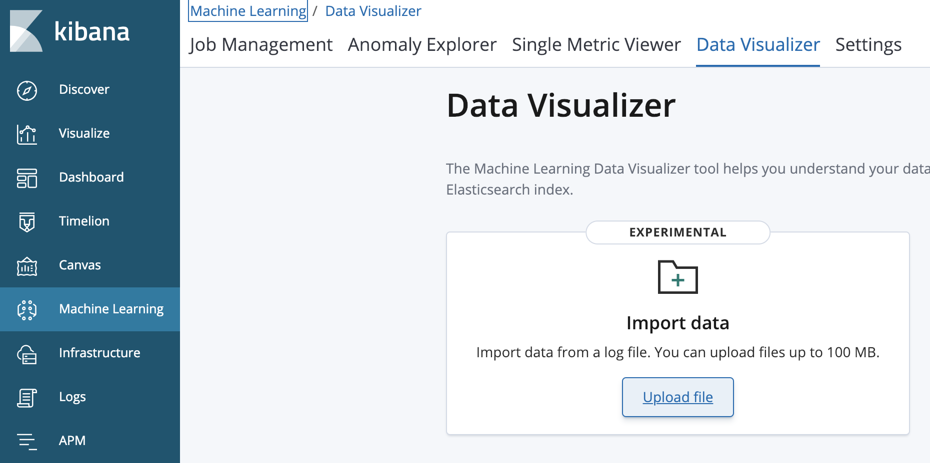

2. Cllick Import

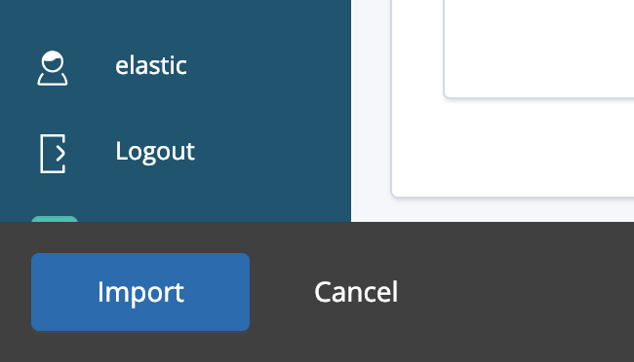

3. Enter the index name “trend_forecast_example”

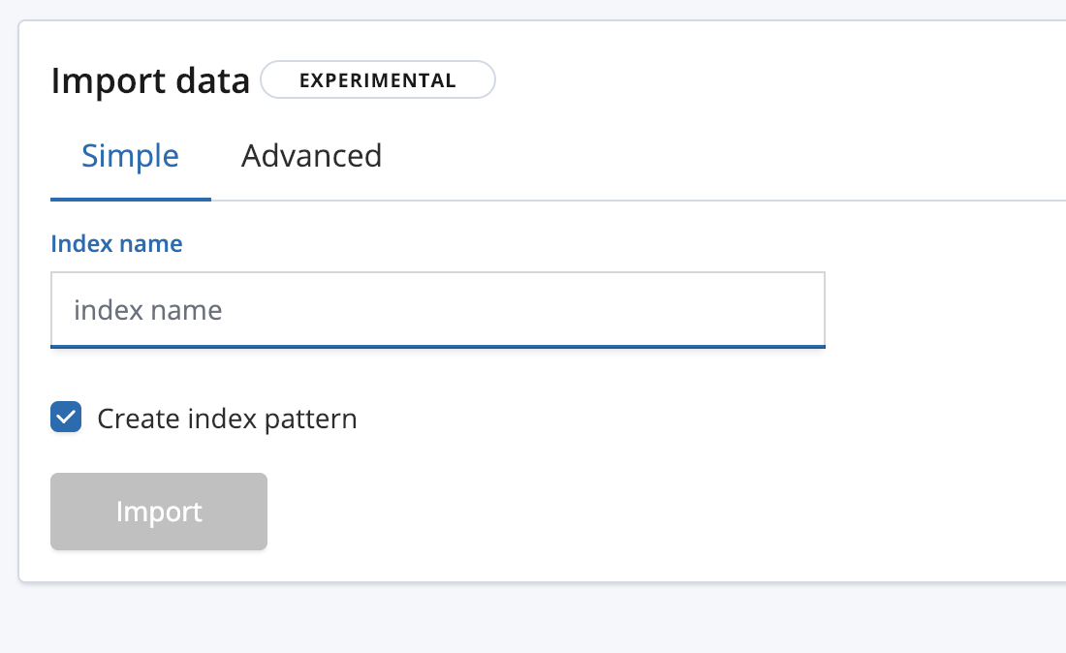

4. Wait for the Upload to finish.

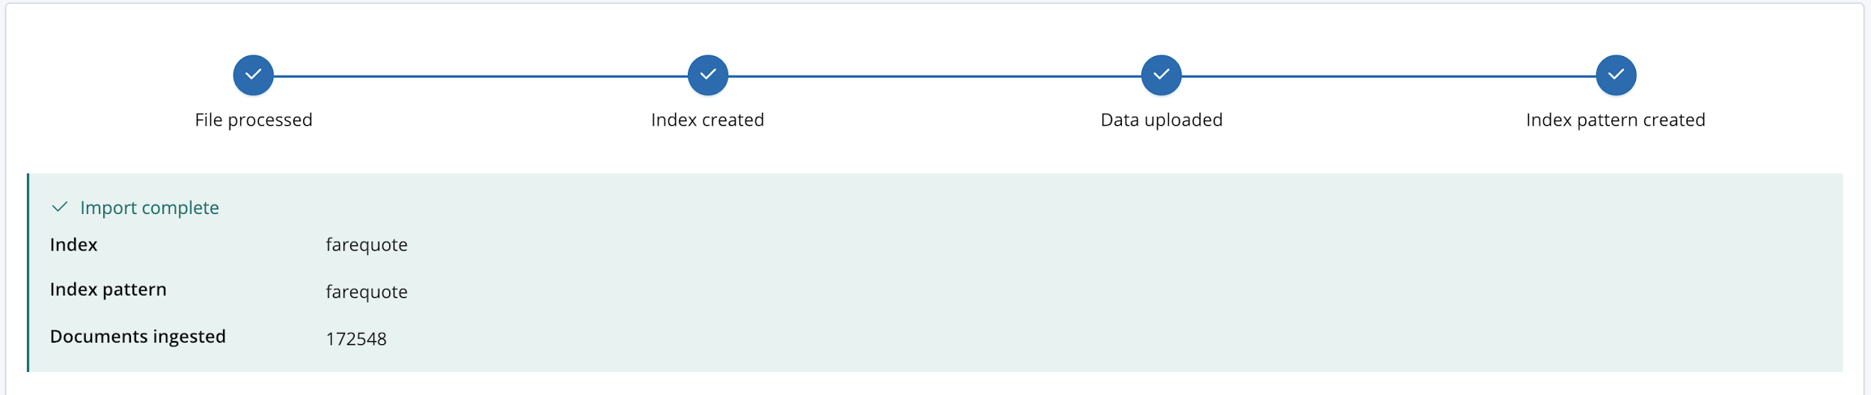

## Create a Machine learning job

In Machine Learning, Create new job

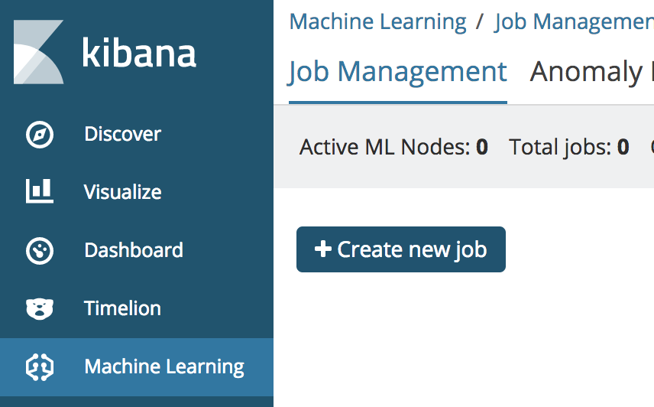

Choose the “trend_forecast_example” index pattern

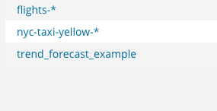

Job config:

* single metric job
* sum of field “amount”
* bucket span: 1h
* click “use full data”
* Name: “forecast”
* click “Create Job”
* click “View Results”

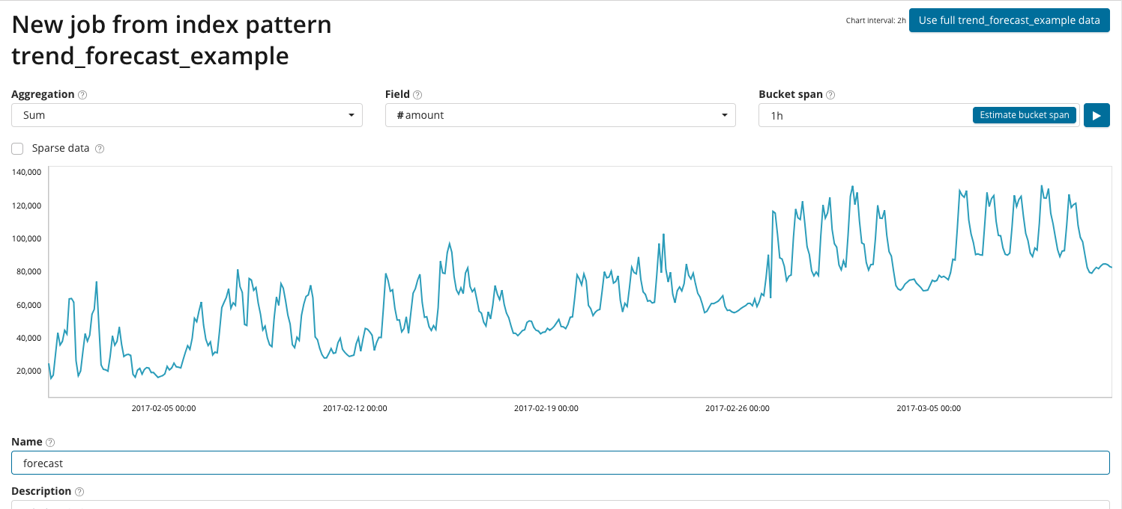

## Run Forecast

* click “Forecast” button
* Enter “7d” for duration
* click “Run” button
* see forecast in UI (results also available via API)

## 